# **✨Bonus✨ Help Wanted**

**Zoe's avatar**

[Zoe](https://substack.com/@zoeffc)

Jul 13, 2024

Share

Hi there!

This is a bonus etter because I want to get this y’all’s input on something.

So here’s the context: I am currently in a phase with my 9-5 where I am navigating some challenging workplace dynamics. It’s the kind of thing that makes me want to scream, or run away, or give up. But I am trying not to do any of those things.

I was talking to my mentor last week and she suggested creating a post-work routine because right now, I tend to turn off my computer and let myself rot for a good 15 minutes - 5 hours. Not great.

**So I want to know: *what are your post-work routines?* Or, if you tend to rot like me… *what would an ideal post-work routine look like?***

[I need to prove to my mentor that I have at least thought about this and… yeah, I’m still stumped.]

Please send help. I want to get this conversation started on our Discord in the [*#rage-room*](https://discord.gg/gsP6MWgq?utm_source=femme-futures.beehiiv.com&utm_medium=referral&utm_campaign=bonus-help-wanted).

This is me crowdsourcing healthy habits…

Zoe

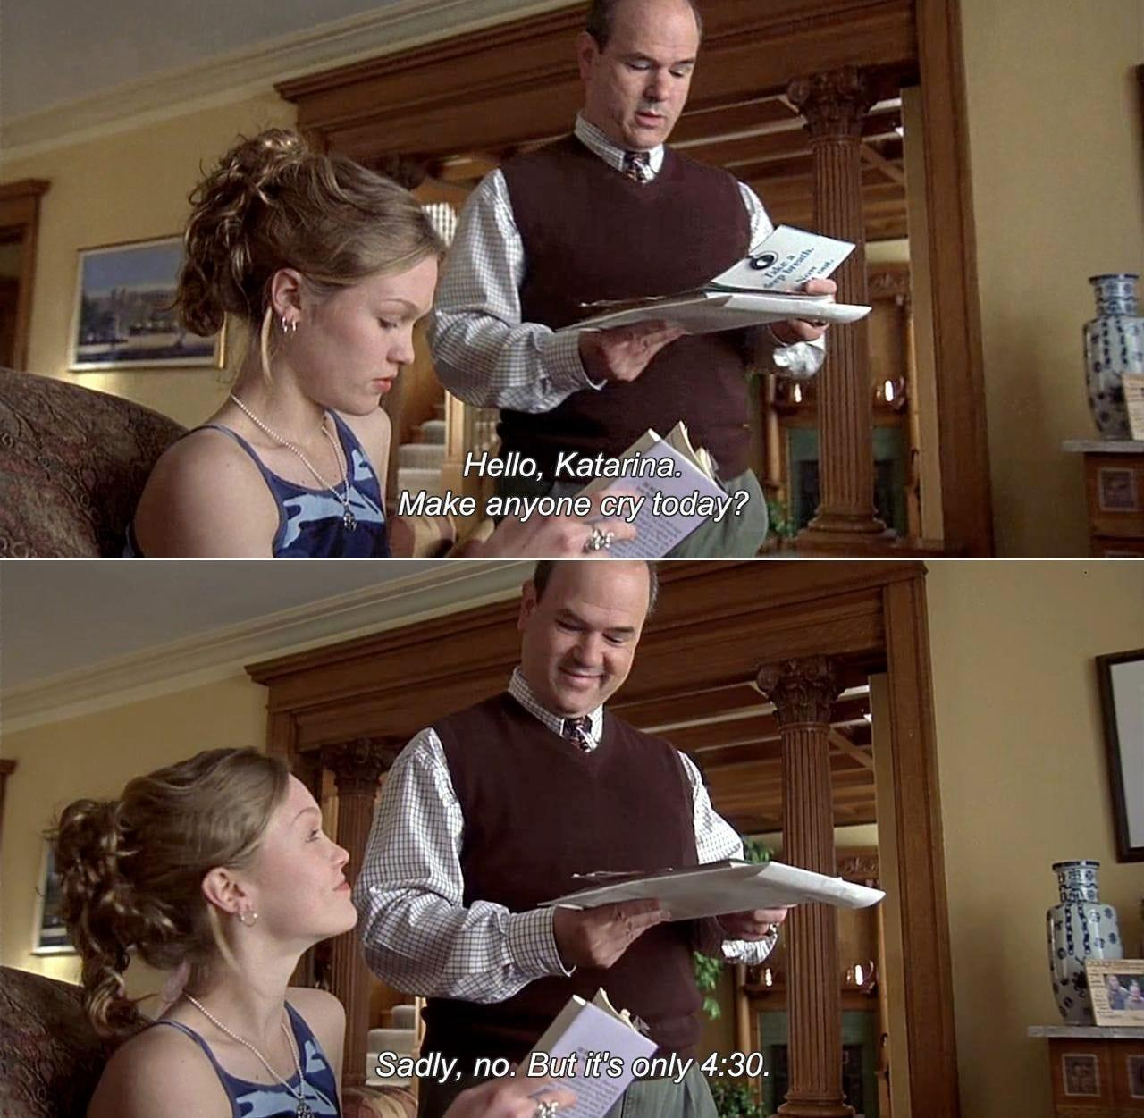

*10 Things I Hate About You*